FMIS iProc Procedures- Transition from Melbourne Health to Western Health
Purchasing at Western Health is handled through the Financial Management Information System (FMIS). This is called iProcurement usually referred to as iProc. iProc creates requisitions and purchase orders. Below is the list of instructions to place an order in FMIS.
- Log into FMIS/Oracle websitehttps://fmisebs.prod.services/OA_HTML/AppsLocalLogin.jsp

- Key in your User Name and Password

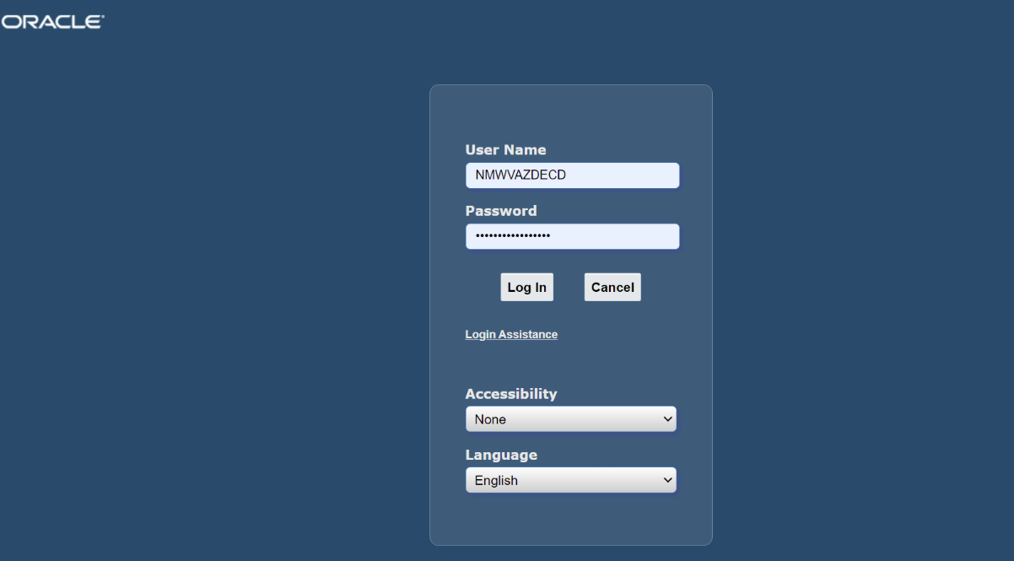

- Select NMW Internet Procurement

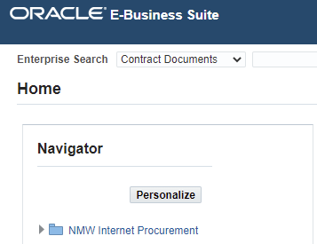

- Click on “Settings”

- Select “Preferences”

- Select “iProcurement Preferences”

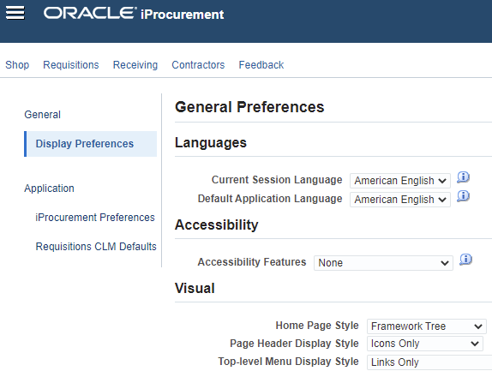

- If you have any favourite charge accounts set up, please ensure that you delete them and set them under Western Health organisation i.e. WH001.WSH

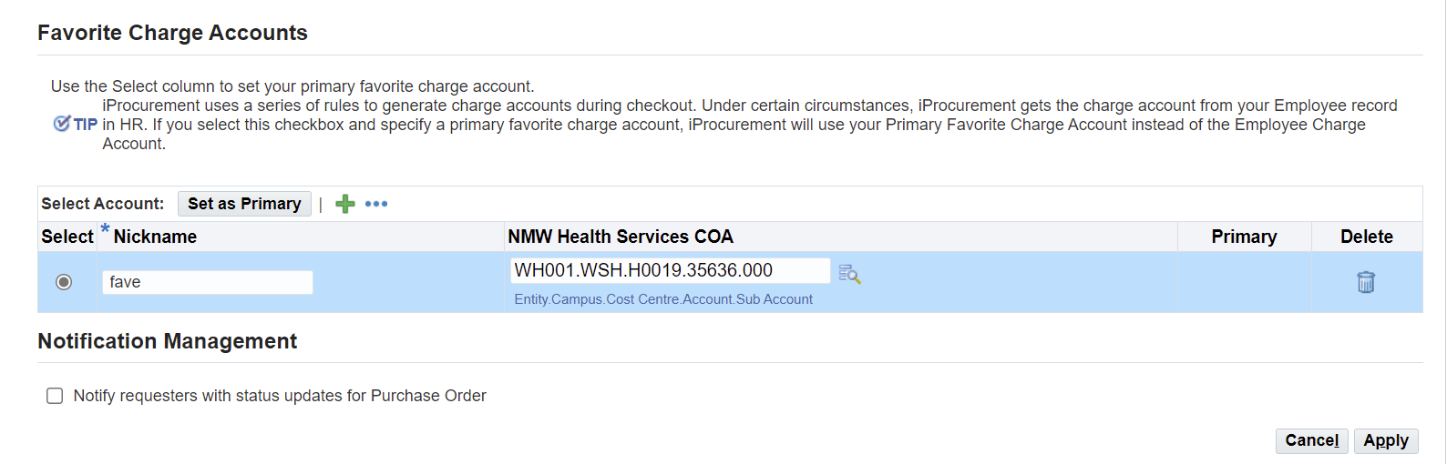

- Every Cost Centre Manager has a delegation to approve within $10k of operating expenditure in FMIS. (Please refer to Delegation of Authority page 11)

Please feel free to contact Donna Johnston (Project Manager-Mental Health Finance Transition) or Vicky Wong (Finance Business Partner – Mental Health Finance Transition) if you require any assistance.

