DONM Leadership Walk-Around Template
Environment | Visual Inspection  - How does the area make me feel?  - What do I hear, see and smell? | Deference to expertise  Discuss observations with staff and patients  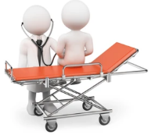  - Is this an issue?  - What has been tried?  - What do we need to do to make this better?  - How can we achieve this? | Reluctance to simplify
 | Positives | Positives | Potential Actions
 | Opportunities | Opportunities
Staff | Sensitivity to operations  Preoccupation with failure. Resilience  - What is the staff experience?  - What are staff worried about?  - Are you aware of any good catches/near misses (incidents/feedback)? | Deference to expertise  Discuss identified opportunities with staff  - Do you think this is an issue?  - What has been tried?  - What do we need to do to make this better?  - How can we achieve this? | Reluctance to simplify
 | Positives | Positives | Potential Actions
 | Opportunities | Opportunities
Patients | Sensitivity to operations Preoccupation with failure. Resilience  - What has the patient experience been?  - What are patients worried about? | Deference to expertise  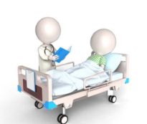  Discuss identified opportunities with patients  - What do we need to do to make this better?  - How can we achieve this? | Reluctance to simplify
 | Positives | Positives | Potential Actions
 | Opportunities | Opportunities

