What is the intention of Standard 2?  This standard aligns with the governance of Best Care and aims to ensure that consumers are partners in the design, delivery and evaluation of healthcare systems and services, and that consumers, carers and/or their family are supported to be partners in their own care.  In your daily work, how do you partner with patients, their family members and carers?  - Introduce yourself to patients and carers whenever you interact with them  - Seek to involve patients and families/carers in care decisions to encourage patient centered decision making at the Bedside during handover  - Communication Board  - Completion of “About Me” form  Why is it important to partner with patients and consumer?  - Ethical and human right  - Improve safety and quality of care  - Meet the patient needs and preferences  - Improve health outcomes  - Patients satisfaction and positive experience  How do you identify and link patients of Aboriginal and Torres Strait origin with suitable support services?  - On admission and recorded in IPM  - Referral to Aboriginal Hospital Liaison Officer  What do you do if a patient would like to see a copy of their care plan?  - Notify NUM/NIC to explain the process  - Provide a copy of the FOI form  Being Accreditation Ready means that …  Ensuring staff have undertaken and follow the “Hello My Name is” WeLearn module  Ensure that patients are asked if they identify as being of Aboriginal &/or Torres Strait Islander (ATSI) decent  Ensuring staff respond to patients, visitors and other staff in a culturally appropriate way  Ensuring there is good communication with patients and families/carers & they are involved in care decisions  Looking for and actioning opportunities to engage consumers in the review and improvement of care / service delivery  If you have specific questions or requests about accreditation readiness, please email: BestCare@wh.org.au  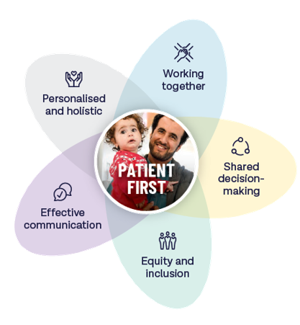 | At which point in a patient’s care journey is it most appropriate to identify their cultural and language needs?  - On Admission/initial contact with Western Health  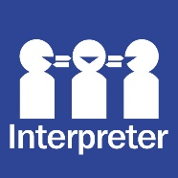  Are you aware that patient rights and responsibilities are outlined as part of the Australian Charter of Healthcare Rights? How would you access a copy of the Charter?  - Yes - Information found on the internet site  - Posters are visible on the ward and brochures for Victoria are available  Where do you refer a patient who wanted to make a complaint?  - Refer to NUM/NIC  - Feedback Form – paper or website  How would you suggest a patient provide feedback on their care?  - Paper Feedback Form  - Email: feedback@wh.org.au  - Feedback Form on website  Refelctive Question …  Describe an improvement in your area that was informed by patient feedback...  Being Accreditation Ready means that in your area …  Communication Boards are up to date  Feedback brochures are available and up to date  Patient information brochures demonstrates consumer endorsed logo  Victorian Charter of Healthcare Rights posters are visible  Are there resources I can access?  Resources are available on the Live Best Care site. Click here or use the QR code below to access the site.  Pop Quiz …  Have a go at a quick pop quiz on Communicating for Safety to test your knowlege! Click here or on the QR Code to access the quiz.  Accreditation Readiness Hint – Standard 2:  The good news is we are already providing Best Care and living up to the requirements of NSQHS Std 2 on Partnering with Consumers in our everyday work! This year's Accreditation Survey is simply a chance to show once again show how well we provide person-centred care.

