What is the intention of Standard 8?  This standard aligns with Safe Care & aims to ensure that acute deterioration in a patient’s physical, mental or cognitive condition is recognized promptly and appropriate action is taken.  How would you identify a patient who is deteriorating?  - Any observation that falls into a shaded area of the observation chart on the Adult Observation and Response chart (WH AD 315) or within any of the vital signs entry components of the Electronic Medical record (EMR)  - An observation falling into the Urgent Clinical Review shaded area requires a doctor from the home unit or covering home unit to review the patient within 30 mins of the escalation.  - An observation falling into the MET response (Medical Emergency Team) shaded area requires the MET team to review the patient within 10 minutes of the escalation.  - If urgent attention is required within 5 minutes call Adult Code Blue 2222 or your approved local area number.  How often do you assess patients at risk of deterioration?  - At the commencement of each shift, at least 3 times a day (in the absence of a documented monitoring plan)  - On admission or transfer to a new clinical area:  - From ED: a minimum of 4/24 for 24/24 unless otherwise documented by the medical staff (except for palliative patients)  - From ICU: a minimum 4/24 for 24/24 unless otherwise documented by medical staff  - To sub-acute: minimum TDS vital signs for 24/24 then minimum daily  - Frequency of Vitals and observations sign recording must comply with the frequency stated in the nursing care plan.  - All patients must have the observations recorded if there are any signs of deterioration or they have an adverse event  - A set of observation are documented prior to discharge.  How would you include patients and their carers in the identification of unexpected deterioration?  - Discuss patient’s usual cognition state and what is normal for the family/carer  - Ask family to communicate any concerns regarding the patient with you  Being Accreditation Ready means that …  Ensuring staff have undertaken deteriorating patient related training in the past 12 months (BLS as a minimum)  Ensuring staff know how to recognise acute clinical deterioration  Ensuring staff know what, when and how to respond to acute clinical deterioration, including mental state  Ensuring staff know their responsibilities in a MET call / code blue situation  Ensuring patients know about “Call for Help” and staff know what to do when it is activated  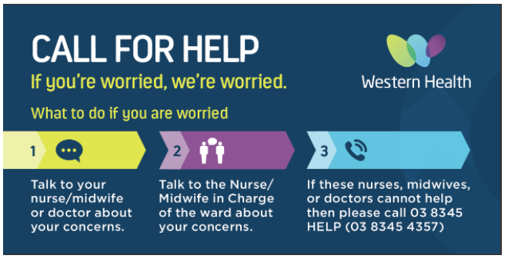  Accreditation Readiness Hint – Standard 8:  The good news is we are already providing Best Care and living up to the requirements of NSQHS Std 8 on Recognising & Responding to Acute Deterioration in our everyday work! This year's Accreditation Survey is simply a chance to show once again show how well we provide safe care.  If you have specific questions or requests about accreditation readiness, please email: BestCare@wh.org.au | What are the symptoms on observation charts that will help you identify an acute change in conscious state?  - Using the AVPU scoring scale  - A: the patient is Alert  - V: the patient responds to Verbal stimuli  - P: the patient responds to Painful stimuli  - U: the patient is Unresponsive  Do you know how to escalate if your patient has acute change in conscious state?  Alert  To Voice Urgent Clinical Review (UCR)  To Pain MET Call  Unresponsive Code Blue  When would you make a MET call?  - If a patient has one of the clinical markers in the shaded areas on either the General Adult Observation or Response Chart or WH Electronic Medical Record (EMR) that corresponds to UCR or MET criteria If I am worried about the patient  - If there has been no attendance to an Urgent Clinical review within 30 mins of the call  - The patient’s condition has not responded to treatment from the Urgent Clinical Review.  What is a “Call for help” and what is your role when this is actioned?  - Call for HELP allows patients, family members and carers to directly escalate their concerns regarding patient clinical deterioration  Clinical staff Role:  - Active engagement in listening to and responding appropriately when patients, family members or carers voice concerns of clinical deterioration even if clinical markers are not abnormal  - Understanding the patients, family members and carers can escalate calls for HELP when they are concerned that their health is deteriorating  Communications staff role:  - Communications staff will receive, forward and log call for HELP calls  Refelctive Question …  How has your area improved recognising and responsding to acute deterioration?  Being Accreditation Ready means that in your area …  “Call for Help” posters are visible  Defibrillator checked daily and evidence available i.e. checklist  Resuscitation trolley, emergency equipment is checked according to schedule and checklist  2222 stickers on all phones (Bacchus Marsh and Melton from July 1st)  Are there resources I can access?  Resources are available on the Live Best Care site. Click here or use the QR code below to access the site.  Pop Quiz …  Have a go at a quick pop quiz on Communicating for Safety to test your knowlege! Click here or on the QR Code to access the quiz.

